
Nghonda Jean Pierre

COLONIAL CARTOGRAPHY AS THE DIPLOMATIC TOOL IN THE TERRITORIAL FORMATION OF KAMERUN (1884-1916)

Nghonda Jean Pierre¹ and Saha Zacharie²
¹National Institute of Cartography, P O Box 157 Yaounde, Cameroon
enpcam@yahoo.com
²The University of Dschang, P O Box 262 Dschang, Cameroon
sahazac@yahoo.fr

ABSTRACT:
The rush for colonies in Africa in the 19th century by European powers was characterised by ferocious rivalries involving England, France and Germany. In the Gulf of Guinea and especially over territories which became Cameroon, that race for land possession led to systematic and renowned boundary agreements between these governments over their respective colonial sphere. Our scrutiny of these agreements reminds us that maps were an irreplaceable auxiliary or instrument of their diplomacy in the process of sharing the vital and coveted African land.
Whereas maps guiding's role for missionaries, armed forces, ruling staff, tradesmen and other users is well-known, its reliability as diplomatic and legal device of conquest is as yet covert.
With the help of several surveys and archives and thanks to transversal approach involving Law, History and Geography, we would like to assess in a suitable manner the role actually played by cartography in the course of the territorial building of Kamerun. This paper precisely shows the territorial evolution of Kamerun step by step through bilateral Treaties clauses and accompanying maps that portrayed the demarcation of international boundaries following various diplomatic summits between Germany and her two major rivals.

Key-words: Boundary demarcation, Colonial rivalries, Diplomacy, French Equatorial Africa, Kamerun, Map, Treaties, Nigeria.

INTRODUCTION
In her relationship with overseas, Africa experienced at the 19th century two major events which are the return to slave trade (consecutive to the abolitionist movement) and the growing European colonial implantation. This implantation took place in a rivalry climate for the European powers, notably England, France and Germany brought on the African land their traditional conflicts and grudges. The land that was going to become “Kamerun”, in other words the German Cameroon, is the prototype of these colonial rivalries. Using strength and diplomacy, each of these protagonists tried to win over her opponent.
For this purpose, cartography played a role that is often underestimated. Administrators, armed forces and plenipotentiaries have often turned instinctively to maps which at the time happen to be a relatively rough tool compared to that of today (Nghonda J P & al, 2005). Honestly, the use of map by French, English and Germans in their quest of lands or territories in Africa and more precisely in the Gulf of Guinea is an ambiguous question. Is it a purely technical tool or an imperialist instrument? Nevertheless, maps were regularly used to delimit the borders of Kamerun with neighbouring French and English possessions. It appears to be very interesting in this work to evaluate the scope of the use of cartography within the diplomacy of colonial powers in Africa and for instance in the delimitation of German Kamerun while keeping in mind the ingenuity deployed to hurriedly supply the latter with the so called “Moisel maps”.
As such, it is convenient to put back the facts within their historical context before revisiting some treaties that cited or made use of the said maps.

I. A CONTEXT OF RIVALRY
In Europe, the search for supremacy had since given way to intense and ferocious rivalries between the great powers. In the 19th century, economic transformation as a result of the industrial revolution revamped leadership competition this time on colonial terrain. For a long time, Germany in a search of its unity remained without this colonial agitation. The end of the 19th century witnesses the reorientation of the German chancellor favoured by the emergence of a regain of rivalry: nationality movement, race for armaments, conquest of new markets, raw materials and social tensions.

1. European rivalries
From the reunification of Italy in 1866 under the leadership of Cavour and that of Germany in 1871 under the Prussian leadership of Otto von Bismarck, a new political map of Europe substituted that built under the banner of Sainte Alliance and carried away by the revolutions of 1848-1852. at the same time, the decline of the Ottoman empire opened the way to the covetousness of the English, French, Russians, Austro-Hungarians, thus the many nationality conflicts in the Mediterranean basin and particularly in the Balkans, on the strait of Bosphore, Dardanelles and Egypt.
Franco-English rivalry: on the 14 July 1789, the storming of the Bastille marked the beginning of the French Revolution and a great drive into a period of more than 10 years in the breakdown of personal ambitions, ideological and strategic conflicts. Exploiting the chaos, Napoleon Bonaparte took over power, restored order in his own way and exported revolution on European kingdoms and empires through wars referred to as Napoleonic (1799-1815). England plays a decisive role in the coalitions formed against the memorable ride or thrust of Napoleon who was finally defeated at Waterloo. The Vienna Congress (1815) as a result of this defeat redrew the political map of Europe.
Germano-French rivalry: the Franco-Prussian war (1870-1871) in view to the reunification of Germany saw the military defeat of France at Sedan and the sustainable amputation of Alsace-Lorraine to the benefit of the Reich. While Bismarck was trying to consolidate the political unity of Germany and his leadership, the Russian, English and especially French vowed him intimate or undying hatred.
Germano-English rivalry: England had for long acquired a privilege position in the mastery of seas and did not appreciate the fact of seeing Bismarck’s Germany in the energetic race for armaments and particularly in the quest of naval armament. In other words, the two powers were engaged in a long economic competition.
Threats to the territorial integrity and honour, coalition and leadership substitutions were the springboard of increasing tensions that was rapidly exported from Europe towards African lands where victims wanted to retort strongly and vanquish to consolidate their achievements.

2. Colonial rivalry and Kamerun
Before 1884, Bismarck’s Germany was reluctant to the rush towards overseas colonies, inspite of the loud petitions expressed by the business sphere, notably these of Hambourg and Breme. The surprise of the French and especially the English was great when Nachtigall ratified the Germano-duala treaty of July 12, 1884 preceding England who apparently had the favour of the Dualas. Each of the great powers had a plan of “civilisation” or of occupation of Africa reproduced on the map below.

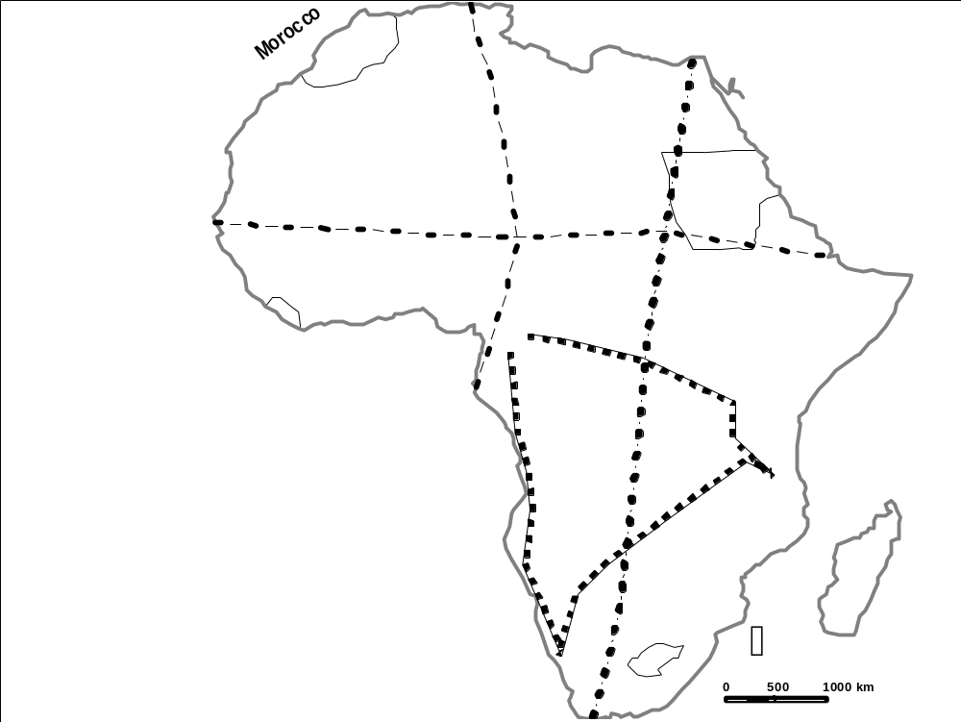
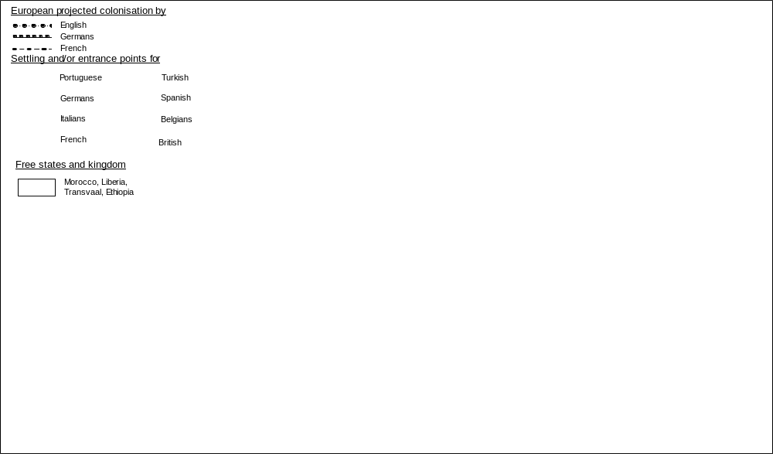
Source: Freeman-Grenville G.S.P. A Modern Atlas of African History, London, 1976, p46.

Map 1: Colonial Projects and land occupation in 1890

Ambitions and English claims: The British project “Cape town Cairo” initiated by Cecil Rhodes was initiated and executed within clashes amongst which we have the Transvaal war, African resistances and conflicts amongst European powers, like Fachoda of September 19, 1898 between Lord Kitchener and Marchand. This project was directly in conflict with the ambitious of France and Germany.
Ambitions and French claims: France wanted territories between Dakar and Djibouti on the one hand and Alger and Libreville on the other hand. It clashed directly with English and German interests; thus the tension and open conflicts of Fachoda in Sudan and in Congo between Brazza and Stanley (Gilbert Houlet, 1962: LXXXVI).
Ambitions and German claims: Thanks to a strategic position acquired in the Gulf of Guinea at the borders of western and central Africa, Germany dreamed of creating its Mittel Afrika. This central Africa empire was to be made up of marked territories as illustrated above (Thierno M. Bah, 1986: 271).
Cameroon was directly at the centre of rivalries as a result of its geographic situation and its natural wealth equally attracted covetousness. Martel quoted by E. Mveng said in Cameroon everything grows and that its sub-soil was larded of gold and tin; etc (E. Mveng, 1985: 147). We could equally add the population estimated at more than 2 500 000 inhabitants (http://www.jaduland.de/kolonien/afrika/kamerun/index.html consulted in March 13, 2005).
Having established basic points at the coast, penetration was done with clashes, both in the great fluvial basins (Nile, Niger, Zambezi and Congo) as well as within the desert zones of Sahara and Namibia, thus necessitating the holding of the Berlin conference.

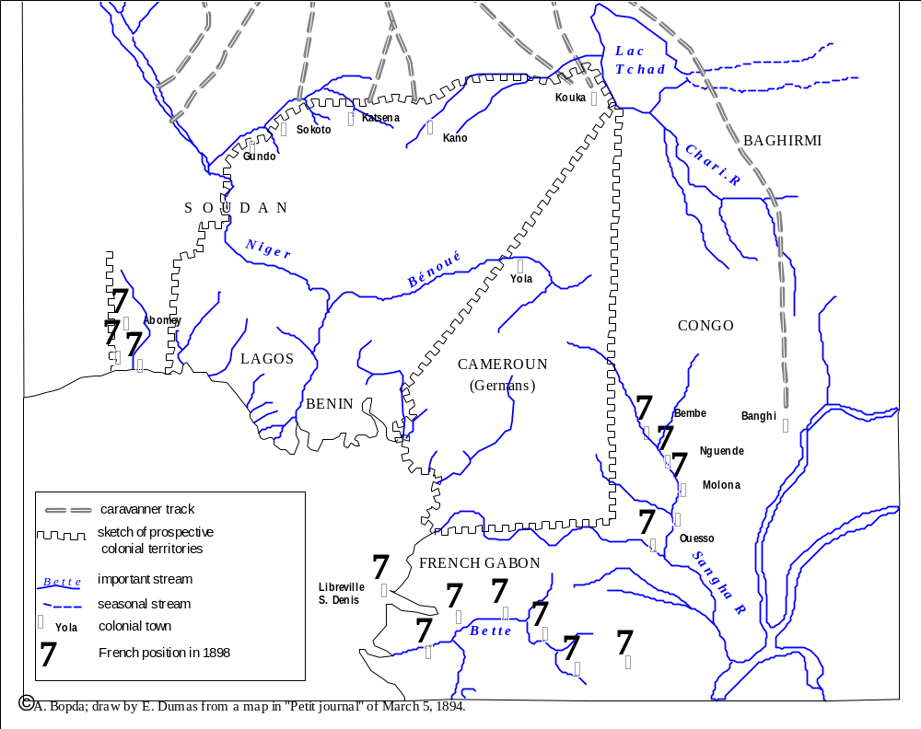

Figure 2: European colonial powers taking root in Cameroon and its surroundings

II. THE TREATIES
Most of the treaties relative to the frontiers of colonial possessions or colonial empires were signed between bilateral frameworks. Nevertheless and though late; the general act of the Berlin conference remains the formal multilateral juridical framework that validated the principles of occupation and appropriation of African land.

1. General Act of Berlin as basic accord
This Act is the prototype of multilateral treaty that served as basic law to the mode of dividing or conquest of Africa. Most of the participating states were really engaged in the colonisation of African land and were able to ratify or confirm the ongoing consensual modalities. Precisely, it refers to the principle of Hinterland which states that great powers holding possession of a portion at the coast could, if desired, extent its hold on adjacent lands of the hinterland until meeting another great power. There were equally obligations of signing treaties with local chiefs. Such are the major clauses relative to the expropriation of African lands and their delimitations amongst colonial powers. Bilateral agreements later permitted the solving and ratification of territorial properties.

2. Germano-English accords (1885-1913)
Bilateral agreements or accords are typical of arrangements relative to the delimitation of colonial possessions. It equally has the priority of being specific in precise cases while multilateral treaties only serve as a juridical framework of reference. These accords and treaties are so many and we shall only mention the most important. Those concluded between Germany and England is relative to the Kamerun-Nigeria frontiers. They were signed both in London and Berlin and in the colony.
April 21, 1885 Accord: This convention gave Germany the whole coast up to the head land near the mouth of the Cross River, then a line linking this point to the old falls of Calabar (E. Mveng, 1985: 61).
April 29-June 16, 1885 Accord of London: It concerns a specific geostrategic sector i.e. “the respective spheres of influences in the gulf of Guinea”. This strategic position is thanks to its maritime facade, a real entry port for the vast region of the hinterlands. It has amongst others irrefutable commercial advantages since the Portuguese exploration of the 15th century. The treaty itself has a wide psychological sphere since it was signed immediately or a little time after; the forceful intervention of the Germano-duala treaty of the 12th of July 1884 at the nose and beard of rivals. It is said that this consent or agreement “dissipated all misunderstanding” between the two powers (Münster in Dr Ruppel, 1912: 1-2 and A. Owona, 1996: 41). It stipulates that the frontiers between the German and English sphere on the coastal sector passes through the right bank of the Rio del Rey, which enters the Atlantic ocean at between 8°42’ and 8°46’ East of the Greenwich Meridian (Dr Ruppel, 1912: 4-5; Anonymous, 1994: 5).
Additionnal Agreement of May 6, 1886: It prolongs the coastal frontiers up to the environs of Yola, jealously maintained within English zone at the level of the Benoue River (E. Mveng, 1985: 61).
July 27-August 2nd, 1886 Agreement of London: As a result of diplomatic exchanges, the two parties agreed to pursue their efforts at the East of Rio del Rey up to Yola (Anonymous, 1994: 5; Ayuk Walters Tankang: 9).
Agreement of 29th March 1887: Through an arrangement of March 29, 1887, Victoria within the Ambas Bay (present day Limbe) passed to the Germans in compensation of an indemnity of 4000 pounds between the Baptists Missionaries and of London who were the rightful owners and the Bâle Mission society (A. Owona, 1996: 43).
April 14 1893 Agreement: This agreement modified the initial frontier and defined “a temporal demarcation line from the Rio del Rey creek, at the right bank, up to longitude 9(8°) 8’ on the English map of 1884-1885 towards the north” (Dr Ruppel, 1912: 4-5; Anonymous, 1994: 6; Ayuk W. Tankang: 9).
Other Agreements: The Agreement of 14th August 1893 defines the Kamerun-Nigeria frontier of Yola at the neighbourhoods of Lake Chad (Dr Ruppel, 1912: 7-10; E. Mveng, 1985: 61). It was followed by the Berlin agreement of 15 November 1893 that pushed the frontier up to Lake Chad. With time, many missions were sent to the field to demarcate these frontiers that were hastily drawn on the map. Together with E. Mveng, we can sight the Moll-Von-Seefried missions (1902-1903) and Cottes-Foerster missions in 1905-1906 (E. Mveng, 1985: 63). New agreements were equally signed. It is the case with the 19th March 1906 Protocol based on the frontier section from Yola to Lake Chad; the protocol of 20th April which shifts the frontier from Rio del Rey to the mouth of Akpa Yafe and 6th October Agreement 1909 agreement which redefined the frontiers from Yola to the sea (Anonymous, 1994: 6-7; Ayuk Walters Tankang: 10).
The Anglo-German Agreement March 11, 1913: this Agreement is based on tracing the frontier between Nigeria and Kamerun from Yola to the sea. With the support of a map, it seams to have solved “all probable ambiguities” related to the matter (Anonymous, 1994: 6).
The Obokum protocol of 12th April 1913: It delimits the Kamerun-Nigeria frontier from Yola in the North to the Cross River in the coastal South. It is accompanied by 8 maps (Anonymous, 1994: 7)!
In the same way, the Germans employed themselves to the search of a tacit approval of Kamerun frontiers with French Equatorial Africa.

3. Franco-German Agreements (1885-1911)
These Franco-German boundary agreements were based on the trace border between Kamerun and French Equatorial Africa. Of these agreements we shall retain just the most important ones.
The Berlin Protocol of 24th December 1885: Through this agreement, Germany renounced the territory situated south of river Campo. This frontier corresponds to a line following the said river from its mouth to where it meets the meridian situated at 10° longitude East of Greenwich (7°40’ of longitude East of Paris) and from this point, the parallel is prolonged up to where it meets the meridian situated at 10° of latitude East of Greenwich (12°40’ of longitude East of Paris). In return, France renounced all territorial claims at the North of this line. At the South-eastern Extreme, Kamerun was touching Sangha, an affluent of Congo and in the Northeast, we witnessed the formation of the “beak of duck” (Dr Ruppel, 1912: 10-25; E. Mveng, 1985: 60).
The Berlin Protocol of 24 February 1894: This protocol concerns the frontier of colonial possessions in the Lake Tchad region, that is to say, the North-eastern frontier of Kamerun. “The 12°40’ meridian (15° of Greenwich) would have formed the limit of the German sphere of influence up to the 1894, agreement which was to delimit the eastern frontiers of Kamerun (A. Owona, 1996: 49).
Berlin Convention of 18 April 1908: The convention of 18 April delimited Kamerun from French Congo. It ratified former conventions, namely those of 1885 and 1894 which established permanent theoretical frontiers by natural frontiers, which were no doubt more winding but more concrete. Through this agreement, Germany gave France a piece of territory in the Northeast of Kamerun, between the Chari River and the 10th parallel, commonly called “beak of duck”; that is about 7000km². France equally got Binder which was an excellent agricultural land. In other words, France received about 8000km² of land around the localities of Koundé and Kadei. In compensation Germany rendered its communication with Garoua more direct and specially received territorial gains in the south-eastern region permitting the whole of Kamerun to cover an area of 512320km² (A. Owona, 1996:50-52).
The agreement of 4 November 1911: The Moroccan crisis of 1911 as mentioned above, sanctioned by the treaty of 4th November 1911 (FA 1/1 46, NAB; Dr Ruppel, 1912: 18-25). This permitted the Reich to add a territory of 275360km² to the frontiers of 1908 (A. Owona, 1996: 53). This agreement gave Germany part of French Equatorial Africa. In return, Germany was to give France free hands over Morocco and give her the whole “beak of duck”. The treaty was to be effective on the 1st of October 1912 (FA 1/1 46, NAB). Of all the treaties relative to the delimitation of colonial territories in Africa, it is probably the one that frustrated France the most. It is only its short life span, shortened by the First World War that consoled the latter.
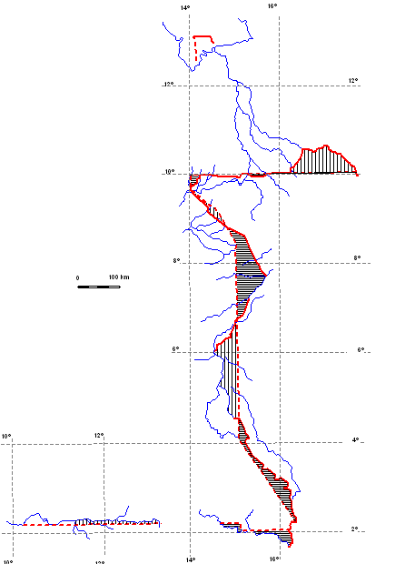
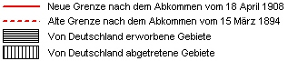
Moisel M, "Abkommen betriefend die Abgrenzung zwischen Kamerun und Französisch-Kongo vom 18 April 1908" in Deutsche Kolonialzeitung, 25 Jahre, Nr: 18, 2 mai 1908, mit Karte, p313; A. Owona, 1996, p 89.

Figure 3: Fluctuating borders of Kamerun and its Eastern neighbouring French Equatorial Africa

4. The permanent worry of cartographic representation within border agreements
It is regrettable that maps accompanying border treaties are no longer found, separated from archives which do mention them. All what we have are text paragraphs describing with rare precision the successive stretches of the demarcation line of the possessions of rival European powers. Article 1 of the Berlin convention of April 18, 1908 divided the border trace into 34 stretches and described them individually and by privileging the most known structures of the time. In fact, these stretches were identified with the aid of permanent physical objects within the landscape and which were easily materialised on the map like the toponym for 12 cases, streams in 3 cases; line of watershed including longitudes and latitudes. It should be noted that 50% of this French Congo-Kamerun frontier as described by 2 or 3 of the above mentioned objects simultaneously. This was in obedience of the need for cartographic precision and valorisation maps elaborated by the route survey approach exactly along the streams (Nghonda J.P. & al 2005). Furthermore, article 6 of the same agreement gave the position of 10 boundary stones while precising differences in metres on both sides of 2°10’20’’. For the Anglo-German agreement of 11 March 1913, article 20 took in consideration the dynamism of rivers to the extent of indicating that the “Bakassi peninsula remains cameroonian even if river Akpa Yafe changed its course as it entered Rio del Rey”. In the same way in Berlin protocol of December 25, 1885, it is said that if river Chari (which delimits Kamerun and French possessions) at its mouth flows in many arms to Lake Chad, the main arm shall be considered as the border line (L’Illustration N°2681, 14th July 1894, p34). Described with full details and even mapped, the frontiers nevertheless remain an object of disputes, notably when the geopolitical rivalry which was initially to German advantage, changed hands as a result of the 1914-1918 war.

5. Closeness of diplomatic agreements and Moisel maps publication dates
Germans published belatedly the topographic Moisel maps carrying a tracing of the international border of Kamerun. These 23 leaves are shown below per date of publication.

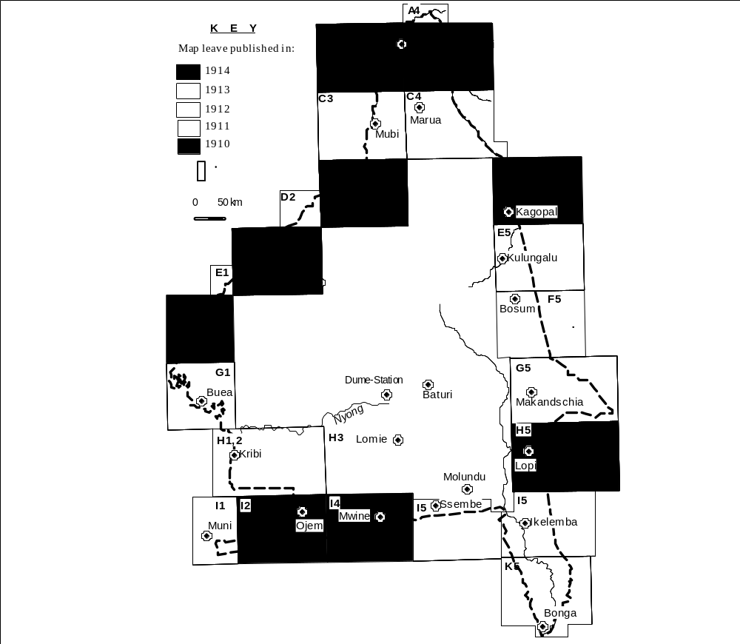Source: Vohsen, Ernst (ed.) Karte von Kamerun in 31 Blatt und 3 Ansatzstücken in Maβtabe 1:300000 bearbeitet unter Leitung von Max Moisel.

Figure 4: Moisel map leaves carrying a tracing of Kamerun international border

It is in 1911 that the diplomacy stretches the borders of the Kamerun to their maximal extent. In 1911, only two (2) Moisel maps showing the coastal line as defined in the agreements of 1885 were published. A year after in 1912 whereas the Germano-French agreements had just been signed few months earlier, fourteen (14) maps at 1:300000 were published and 9 out of the 14 carry sections of the Kamerun-French Equatorial Africa border. Furthermore, year 1913 is the term of the Anglo-German agreements on the western border of the Kamerun and 3 of the 4 Moisel maps published in 1913 carry each a segment of the aforesaid border. Shall we say it is nothing than just a coincidence?
The colonial Office of the German Empire endorsed its Institute of Cartography which freed it relatively from the publisher Dietrich Reimer Cartography Institute. Mapping work in Kamerun was actually coordinated from Germany and its budget was provided by funds originating from both the colonial administration office and the imperial government in Germany. Table 1 below reports sources and amounts allocated for cartography and related works in 1911 (Dr Ruppel, 1912: 318-320).

Kapital | Titel | Ziffer | Zweckbestimmung | Es sind vorbehalten der Bewirtschaftung |  | Bemerkungen
 |  |  |  | Durch das Reichkolonialamt | Durch das Gouvernement | Bemerkungen
1 | 14 | 4 | Kartographie und Landesvermessung | 3000 marks | 12600 marks

Table 1: Source and amount of funds for cartography work and related disciplines after “Verzeichnis derjenigen Fonds des Etats für das Schutzgebiet Kamerun auf das Rechtnungsjahr 1911, welche in ganzer Höhe oder nur zum Teil der Bewirtschaftung durch das Reichskolonialamt vorbehalten sind”

A look to the budget distribution in 1911 confirms that very few items were like cartography funded by both the German Colonial administration office and the imperial government. Mapping work was actually freed from funds scarcity. Considering the manpower required for Moisel maps and mapping techniques by 1910, we think that the cartographic works were closely associated to diplomacy in the German colonial policy aimed at installing an empire over central Africa region.

III. THE FIRST WORLD WAR AND UNILATERAL QUESTIONING OF FRONTIERS
German presence in Kamerun and Togo was particularly unpleasant to England and France. Furthermore, the Moroccan crisis of 1904, especially that of 1911 had disastrous repercussions on French colonial empire in central Africa commonly named French Equatorial Africa. We understand why, these powers did not miss the uncertain opportunities offered them by the First World War to revenge. Meanwhile chapter III of the final Act of the Berlin conference firmly prohibited European wars within the conventional basin of Congo. The Germans who were not prepared for the violation of the final Act of the Berlin conference were surprised and forced to defend themselves.

1. Franco-German frontiers
Immediately after the First World War breaks out in Europe in August 1914, France precipitated herself on Kamerun. The primary objective of French forces commanded by general Aymerich was the conquest of territories that were given to Germany after the “Agadir coup” or Moroccan crisis in 1911. After the attack of Lukunga by German forces, she succeeded by the end of October 1914 in dragging Belgium along, who was at first fidele to the neutrality clause of the Congo basin (Thierno M. Bah, 1986: 275). The Reich subjects were obliged to give back territories acquired through the 1911 treaty to French Equatorial Africa. In acting this way, France challenged not only the soldiers of lieutenant-colonel Zimmerman but equally international law.
Pursuing its campaign, France questioned, as the forces were progressing on land, not only the 1911 treaty but equally all German possessions situated at the entrance of its own colonial empire in central and western Africa. The localities of Bonga and Zinga, inscribed from the 1st August on the French war plan were removed on the 6th of August (E. Mveng, 1985: 103). England who had never appreciated the German protectorate on Kamerun, a country with which the English had created many affinities, equally did the same. The relation of forces was very hostile to the Germans, but their heroism and their good mastery of the country gave them a two years of grace!

2. Anglo-German frontiers
England as France was not of the idea of restricting the war to European territories. The international context had witnessed much change since 1885. Successive colonial conflicts directly or indirectly oppose Germany to France or England, who saw the irresistible growth of German naval power with a very bad eye because it threatened its maritime and colonial interests around the world (Thierno M. Bah, 1986: 271). Equally she did not hesitate in commissioning German troops in Kamerun.
British troops that took part in the conquest of Kamrun came first from neighbouring Nigeria and then from the Gold coast, Sierra Leone and Gambia (Thierno M. Bah, 1986: 275). The Germans saw themselves surrounded from all sides, from the coast to Lake Chad and from Lake Chad to the south-eastern angle touching Belgian Congo. The English were to play a decisive role that the unequal distribution of territorial spoils of Kamerun does not mention. Many are the territories conquered by the English that were however passed under the French authority.
The whole allied forces or troops were with time placed under the command of the British general C.M. Dobell. Thus the conquest of Douala (September 27, 1914), Yaounde (January 1st, 1916), Garoua, Mora (August 20th, 1916) and many other localities of strategic interest were conquered both by English and French (Thierno M. Bah, 1986: 277-281; E. Mveng, 1985: 110-114), but the alliance broke off as the common danger represented by German forces disappeared.
In like manner, she questioned many treaties or agreements signed with German officials and regularly accompanied by maps and sanctioned by joined missions of demarcation on the field.

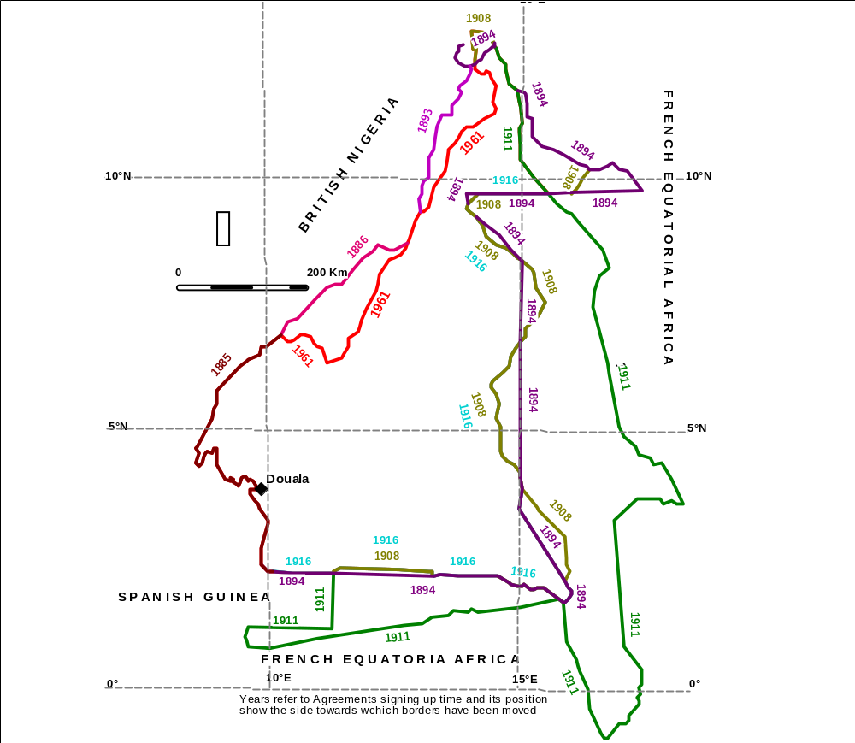
Source: A. Bopda, 2003, p67 and Dr Ruppel 1912

Figure 5: European rivalries transposed over the history and instability of Cameroon borders

CONCLUSION
The above principles and diplomatic suitability, the partition of Africa was essentially a question of a relation of force. In function to the evolution of forces on the geopolitical or geostrategic field, the powers redistributed maps among themselves. In Berlin, Bismarck tactfully forced his rivals to accept his own land appropriation in Africa. Arriving late on a territory he neglected, Bismarck manipulated hardly to ratify possessions that were still unconquered in Togo, South-West Africa and especially Kamerun. His representatives met strong resistance within these territories from the population but equally a silent opposition from England and France who most have wished of not having such adversary within its respective neighbourhood.
In the light of facts, it seems that the real frontier was that which was guaranteed permanently by force. Cartography played a major diplomatic and strategic role but it is convenient to relativize its scope within a context of strong rivalry. Inspired by treachery and the imperialism of great powers, cartography would have been like all other tools in the hands of rival European powers victims of a thousand and one manipulations.
However, it temporally avoided certain territorial conflicts. Today, treaties that emanated from colonial maps of frontier delimitation bring an indispensable lightening in referencing territorial disputes between African states. The Cameroon-Nigeria conflict over the Bakassi peninsula is a good example. It is in fact on the basis of treaties and maps from colonial archives that the international court of justice was able to give its clear point of view over the matter.

BIBLIOGRAPHIE
Anonymous, Arrangement relatif à la délimitation entre l’Afrique Equatoriale Française et le Cameroun, Conformément à l’Accord du 4 novembre 1911, FA 1/146, Archives Nationales de Yaoundé (ANY).
Anonymous, Dossier sur le différend frontalier de la péninsule de Bakassi. République du Cameroun, Yaoundé, 1er mars 1994.
Anonymous, “Abgrenzungarbeiten am Rio del Rey” in Deutsch Kolonialblatt, n° 23, 1 December 1895, p: 620.
Anonymous, Abkommen zwischen Deutschland und England über die afrikanischen Besitzungen. Vom 1. Juli 1890. (Auszug) in Dr Ruppel, 1912, Die Landesgesetzgzbung für das Schutzgebiet Kamerun. Sammlung der in Kamerun zur Zeit gelstenden völkerrechtlichen verträge. Geselte, Verordnungen und Dienstvorschriften mit Anmerkungen und Registern. Auf Grund amtlicher Quelle herausgegeben, Berlin, pp: 3-4
Anonymous, “Abkommen zwischen Deutscland und England über die Festsetzung der Grenze zwischen dem Kamerun- und dem Ölfluβ-gebiete. Vom 14. April 1893.” In Dr Ruppel, 1912, Die Landesgesetzgzbung für das Schutzgebiet Kamerun. Sammlung der in Kamerun zur Zeit gelstenden völkerrechtlichen verträge. Geselte, Verordnungen und Dienstvorschriften mit Anmerkungen und Registern. Auf Grund amtlicher Quelle herausgegeben, Berlin, pp: 4-5
Anonymous, “Abkommen zwischen Deutschland und England über die Abgrenzung der beiderseitigen Interessensphären in den vom Golf von Guinea nach dem Innern sich erstreckenden Gebieten. Vom 15. November 1893.” in Dr Ruppel, 1912, Die Landesgesetzgzbung für das Schutzgebiet Kamerun. Sammlung der in Kamerun zur Zeit gelstenden völkerrechtlichen verträge. Geselte, Verordnungen und Dienstvorschriften mit Anmerkungen und Registern. Auf Grund amtlicher Quelle herausgegeben, Berlin, pp: 5-7.
Anonymous, “Grenzfestsetzung zwischen dem deutschen Gebiete Nordwest-Kamerun und dem britischen Gebiete Nigeria von Yola and bis zum Tchad-See. Vom 16. Juli 1906” in Dr Ruppel, 1912, Die Landesgesetzgzbung für das Schutzgebiet Kamerun. Sammlung der in Kamerun zur Zeit gelstenden völkerrechtlichen verträge. Geselte, Verordnungen und Dienstvorschriften mit Anmerkungen und Registern. Auf Grund amtlicher Quelle herausgegeben, Berlin, pp: 7-10
Anonymous, “Le Cameroun Allemand” in L’Illustration, N°2681 du 14 juillet 1894
Anonymous, “Protokoll; betreffend die deutschen und französischen Besitzungen an der Westküste von Afrika und der Südsee. Vom 24. Dezember 1885. (Auszug)” in Dr Ruppel, 1912, Die Landesgesetzgzbung für das Schutzgebiet Kamerun. Sammlung der in Kamerun zur Zeit gelstenden völkerrechtlichen verträge. Geselte, Verordnungen und Dienstvorschriften mit Anmerkungen und Registern. Auf Grund amtlicher Quelle herausgegeben, Berlin, pp: 10-25
Ayuk Walter Tankang. Basic Facts on the Bakassi Crisis. unpublished.
Bah, Thierno Mouctar. « L’Afrique dans la Première Guerre Mondiale : le cas du Cameroun », in Kum’à Ndumbe III (sous la direction de). L’Afrique et l’Allemagne de la Colonisation à la Coopération, 1884-1986 : le cas du Cameroun, Acte du colloque international Cent ans de relations entre l’Afrique et les Allemagnes 1884-1984 : Le cas du Cameroun. Tenu à Yaoundé du 8 au 14 avril 1985, Yaoundé, Editions AfricAvenir, 1986), pp. 271-286.
Bopda, Athanase. Yaoundé et le défi camerounais de l’intégration. A quoi sert une capitale d’Afrique tropicale ? Espaces et milieux, CNRS éditions, 2003, 422p.
Brunschwig, Henry. Le partage de l’Afrique. Paris, Flammarion, Collection Questions d’histoire, 1971.
Freeman-Grenville G.S.P. A Modern Atlas of African History, Rex Collings London, 1976, 65p.
Gilbert, Houlet (établi par). Afrique Centrale : Les républiques d’expression française, Collection Les Guides Bleus (sous la direction de François Ambrière), Paris, Librairie Hachette, 1962, p. LXXXVI.
Graf V. Hazfeldt; “Abkommen zwischen Deutschland und England über die Ausdehnung der Nordwestgrenze von Kamerun bis zum Benuë. Vom 27 Juli / 2. August 1886.” in Dr Ruppel, 1912, Die Landesgesetzgzbung für das Schutzgebiet Kamerun. Sammlung der in Kamerun zur Zeit gelstenden völkerrechtlichen verträge. Geselte, Verordnungen und Dienstvorschriften mit Anmerkungen und Registern. Auf Grund amtlicher Quelle herausgegeben, Berlin, pp: 2-3.
Herr von Kinderlen-Waechter and Jules Cambon, “Deutsch-französisches Abkommen, betreffend die beiderseitigen Besitzungen im Äquatorial-Afrika. Vom 4 November 1911” in Dr Ruppel, 1912, Die Landesgesetzgzbung für das Schutzgebiet Kamerun. Sammlung der in Kamerun zur Zeit gelstenden völkerrechtlichen verträge. Geselte, Verordnungen und Dienstvorschriften mit Anmerkungen und Registern. Auf Grund amtlicher Quelle herausgegeben, Berlin, pp: 18-25.
Hauptmann Engelhardt, Leutnant Schulz, Oberleutnant Foerster and Stabsarzt Hoesemann, 1901, “Bemerkungen zu der Karte des Gebietes am unteren Kampo (Karte 4) von M. Moisel” in Wissenschaftliche Beihefte zum Deutschen Kolonialblatte. Mitteilungen von Forschungereisenden und Gelehrten aus den Deutschen Schutzgebieten mit Benutzung amtlicher Quellen herausgegeben von Dr Freiherr von Danckelmann, XV Band-3Heft, Berlin, 1902, pp: 129-130. FA C71, National Archives of Yaounde (NAY)
Mveng, Engelbert. Histoire du Cameroun. Tome 2, Yaoundé, CEPER, 1985.
Münster ; “Abkommen zwischen Deutscland und England ûber die Abgrenzung von Interssensphären am Golfe von Guinea. Vom 29. April / 7 Mai 1885” in Dr Ruppel, 1912, Die Landesgesetzgzbung für das Schutzgebiet Kamerun. Sammlung der in Kamerun zur Zeit gelstenden völkerrechtlichen verträge. Geselte, Verordnungen und Dienstvorschriften mit Anmerkungen und Registern. Auf Grund amtlicher Quelle herausgegeben, Berlin, pp: 1-2.
Nghonda, Jean Pierre; Saha Zacharie and Tchindjang Mesmin, “Pioneer work of German cartographer, Max Moisel in Cameroon: An assessment of the colonial era mapping contribution’’, International Cartographic Conference, July 9-18 2005, at Coruña, Spain.
Ngongo, Louis. Histoire des institutions et des faits sociaux au Cameroun, Tome I : 1884-1945, Collection Mondes en devenir, Paris, Berger-Levrault, 1987.
Owona, Adalbert. La naissance du Cameroun : 1884-1914, Paris, L’Harmattan, 1996.

